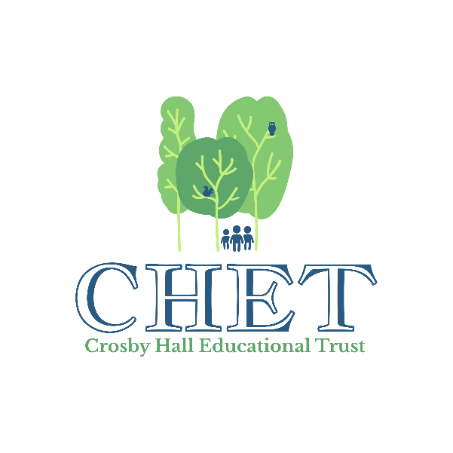
Crosby Hall Educational Trust
Back Lane, Little Crosby, Liverpool, L23 4UA
Telephone: 0151 924 9099
Email: office@chetcentre.org.uk
www.chetcentre.org.uk

Principal: Graham Still-Blundell BSc PGCE
Email: principal@chetcentre.org.uk

PRIVACY NOTICE

What is Crosby Hall Educational Trust (CHET) and what do we do?

CHET is a residential outdoor activity centre in the historic converted stables, farm buildings and grounds of Crosby Hall. The value of residential courses for children is widely recognised, because a period of community living is seen as an essential part of a child's social and educational development, and can release energies and gifts not previously recognised. A period spent in a congenial environment, away from the distractions and pressures of everyday life can benefit students of all ages. Most people today live in urban areas, but the countryside is part of their heritage. At CHET we introduce children to trees and fields, birds and animals, and many stimulating activities.

CHET aims to make CHETs facilities available to all children, regardless of the ability to pay, through a bursary fund thanks to a network of regular supporters (CHET friends) and other donations. CHET also runs various fundraising events each year including concerts, an art and craft fair, an outdoor play and a garden open day.

CHET is a registered charity and a company limited by guarantee.

Why we collect and keep information about you and how we use it

We keep the following basic details about you so that we can provide you with information about bookings you have made or about our events:

- Name
- Address
- Email address (where provided)
- Telephone number

If you are a CHET friend, we also keep the bank details you provided to set up your standing order. CHET friends are also sent letters to keep you informed of developments and/or to invite you to specific CHET friend events.
The information we hold is collected directly from you (the data subject). We are committed to holding your records in strict confidence.
All your information held by CHET is kept safe. Anyone looking at your information, whether on paper or computer, is obliged to keep the information confidential. We will not share your personal data with anyone unless we obtain your consent. We will never share your data with third parties for marketing purposes.

When we destroy your information

We will keep your information until such time as you tell us that you no longer wish to receive information from us. If you would like us to stop sending information to you we will remove your information from all CHET sources.
Your rights

You have the right to confidentiality under the Data Protection Act 1998 (DPA), the Human Rights Act 1998, the General Data Protection Regulation 2018 and the common law duty of confidence (the Disability Discrimination and the Race Relations Acts may also apply).

You also have the right to ask for a copy of all records we hold about you. Your request must be made in writing and you will need to give adequate information (for example full name, address, date of birth, etc). We will generally provide this information free of charge and are required to respond to you within one month. You will be required to provide identification before any information is released to you.

You have the right to rectify your information; if you think anything in your record is inaccurate, please let us know.

You have the right to restrict how we process your information and you can also request that we remove your information altogether.
Who should you contact if you have a query?
CHET is the Data Controller for your personal information; queries should be directed to:

The Business Manager
Crosby Hall Educational Trust
Back Lane
Little Crosby
Liverpool
L23 4UA
Tel: 0151 924 9099 (Option 1)
Email: office@chetcentre.org.uk
Supervisory Authority and Notification
Data Protection is regulated in the UK by the Information Commissioners Office (ICO). You have the right to lodge a complaint with the ICO if you are unhappy with the way CHET has treated your information.

The Information Commissioner
Wycliffe House
Water Lane
Wilmslow
Cheshire
SK9 5AF
Tel: 01625 545745
www.informationcommissioner.gov.uk

CHET has notified the Information Commissioner of the purposes for which they process personal information as required by the Data Protection Act 1998; these details are publicly available from: https://ico.org.uk/about-the-ico/what-we-do/register-of-data-controllers/

Dated April 2018
Last review – February 2023

